Exercises to work out and turn in:
Grading Guidelines (See Appendix):
In general, a right answer will get full credit when:

- It is right (worth 25%)
- It is right AND neatly presented making it easy and pleasant to read. (worth an extra 15%)
- There is an obvious and clear link between 1) the information provided in the exercise and in class and 2) the final answer. A clear link is built by properly writing, justifying, and documenting an answer (worth an extra 60%).
- Calculation mistakes will be minimally penalized (2 to 5% of full credit) while errors on units will be more heavily penalized.

Late Submission : as specified in the syllabus. Day counting starts one minute after the deadline.
Check Your Submission: after submitting, download your submission to check whether it is the right version and it is complete. after submitting, download your submission to check whether it is the right version and it is complete. A wrong version will get at least a 25 points penalty that cannot be claimed back by the Leniency Policy for Borderline Incidents. So, check your submissions.

You are welcome/encouraged to discuss exercises with other groups or the instructor. But, ultimately, personal writing is expected.
- USE THIS EDITABLE FILE AS THE STARTING DOCUMENT YOU WILL TURN IN. KEEP IN THE QUESTIONS AND INSERT YOUR ANSWERS RIGHT AFTER THE QUESTIONS/PROMPTS. DO NOT DELETE ANYTHING IF USING HAND WRITING (STRONGLY DISCOURAGED), REWRITE THE QUESTIONS.
- FAILING TO FOLLOW TURN IN DIRECTIONS /GUIDELINES WILL COST A 30% PENALTY.

Objectives of this assignment:
- to work on a Unix based system
- to become familiar with the notion of a process
- to assess/evaluate the fairness and reliability of the CPU scheduler on Tux machines

What you need to do:
- to work on a Unix based system
- Review a few Unix commands
- Examine C code
- to understand the fork() function to create a ”child” process
- to understand the relationship (or lack of) between parent and child process
- to "experience" the data shared problem
Important:
- One submission per team. You must complete all tasks on an Engineering Unix Tux machine, otherwise a 0 will be assigned.
- Writing and presentation of your report are considered to grade your hands-on lab. Your conclusions must be supported by the data/measurements you collect. Your conclusions must be correct.
- Questions about this lab must be posted on Piazza if you need timely answers.
- Work ahead. Do not wait until the last minute.

(Reminder) In order to save space, for this assignment and future ones, clip out the screenshots to contain only the relevant information (the date, the Tux machine you are using for the question, the Auburn username, and material related to the question/task). A 25 points penalty will be applied when any required information is missing. Make sure that the screenshots are easily readable.

Task 1: Basic Unix Commands (30 points)

(Well written short answers are acceptable for this assignment)
The objective of this exercise is to get familiar with basic frequently used commands.

Task:
In order to save space, for this assignment and future ones, clip out the screenshots to contain only the relevant information. Make sure that the screenshots are easily readable.
Consider these basic frequently used Unix commands:
echo, date, time, more, rm, rmdir

Be careful with the commands rm, rmdir.
For each of the above commands,
- Provide a brief description (you may use the man command, but use your own words ultimately)
Echo- display text to output
Date- display the date and time: day of week, month, day, hour, minute, second, time zone, year
Time- the time command is used to display the execution time of programs
More- display contents of a file by page
Rm- the rm command is short for remove and can be used to remove files or directories.
Rmdir- the rmdir command is short for remove directories but is used to remove specifically empty directories
- Execute the command on a Tux machine. Provide a screenshot.
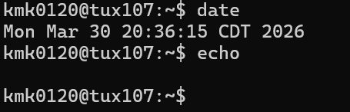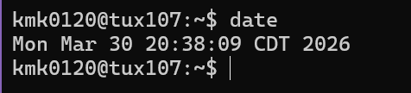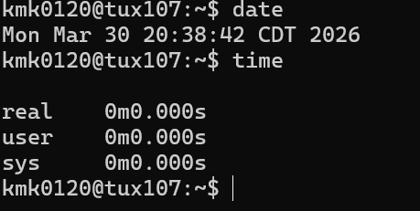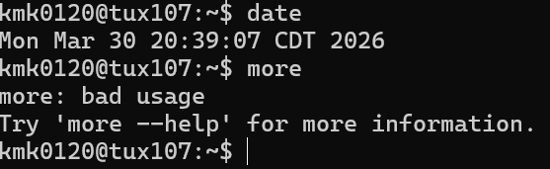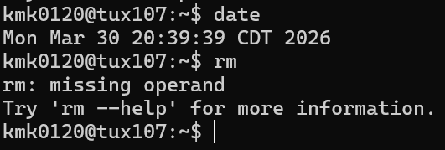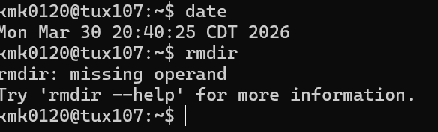
- Briefly comment the results/outcomes of the execution
Echo- it didn’t have anything to display because I didn’t give it anything so it displayed nothing
Date- it printed the day of week, month, day, hour, minute, second, time zone, and year based on my systems clock
Time- there are no programs running so it displayed the execution times of real, user, and sys for system. All were 0 minutes and 0 seconds since no programs are being executed.
More- resulted with displaying “bad usage” because I did not give it any file to page. And gave me the command to ask for help with the more command
Rm- resulted with displaying “missing operand” because I did not give it anything to remove. And gave me the command to ask for help with the rm command
Rmdir- resulted with displaying “missing operand” because I did not give it anything to remove. And gave me the command to ask for help with the rmdir command
- Report any unexpected behavior.
The echo command resulted in a blank response but that’s because we didn’t give it anything to output. The more, rm, and rmdir commands all were used improperly without needed input of files or what to remove so it resulted with it saying why the command was used incorrectly and how to use the help command to find out more about the command I was trying to use. The other commands date and time displayed what I expected.
Insert a screenshot for the rm command.
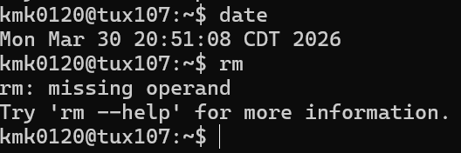

Task 2 (70 points)

The objective of this task is to show you how the shared data problem can lead to incorrect results. Recall that the shared data problem arises when concurrent processes modify shared variables. This task is designed to highlight these conditions. The instructor wrote three programs lab41.c, lab42.c, and lab43.c. These three programs illustrate these conditions, problems, and solution. You must work these hands-on laboratory exercise on a Tux machine.

Exercise 1 (20 points): For this exercise, you must work with the lab41.c program. This program has a parent and child processes supposedly sharing a variable. This program is intended to increment the shared (common) variable counter named *countptr. The parent process is supposed to increment *countptr by increments of 20 while the child increments by 2s. A satisfactory execution of this program may be: the child increments the counter *countptr twice (reaching 4), then the parent increments the counter *countptr thrice to reach 64 ...and so on. When these processes print, we should see the variable always increasing by jumps of 2 or 20. The instructor proposes the program lab41.c and pretends that his program meets the above requirements. Your task is to decide whether this is true or not. You must provide sound arguments to support your decision. Download the program lab41.c. Compile it (cc -o lab41 lab41.c) and execute it (./lab41). Examine the C code and observe the output. Read about the fork() system call. You may consider watching this short Youtube video about fork(). In short, the fork() system call duplicates the parent. The duplicated process is called the child process. This child process is an exact copy of the parent, except that it has a different process ID. Furthermore, the parent and child processes have completely independent memory space. If the parent modifies any of its variables, the "same" variables of the child do not change. Similarly, if the child modifies any of its variables, the "same" variables of the parent do not change. Answer the following questions:
1) (6 points) Does the program lab41.c really execute as supposed (or intended)? Describe the outputs observed. Justify and explain your observations.
Answer here ... (Include a screenshot) The program lab41.c does not execute properly. In the screenshot below it shows that the child process keeps incrementing the counter by 2 and the parent process increments the counter by 20 but the two do not seem to be incrementing the counter together. As you can see below, I split the screenshot into two to show the child and parent processes incrementing the counter at the beginning of the execution of lab41.c and at the end. In the beginning you can see that the child counter starts incrementing by two and increments from 2 to 18 and the parent process is supposed to increment 20 which should make the counter at 18 go to 28 but it says the parent process makes the counter = 20 and then the next child process increments 20 and counter = 20 again. It appears like the two processes are updating different counters when we want them to work to update the counter together. This is happening because the fork() system call makes it so the parent and child processes have different memory spaces and makes it have independent variables so the child and parent processes are updating different copies of the variables. Therefore without a way to deal with shared memory the two processes cannot see how the other is updating the counter and update their own copies independent of the other process.
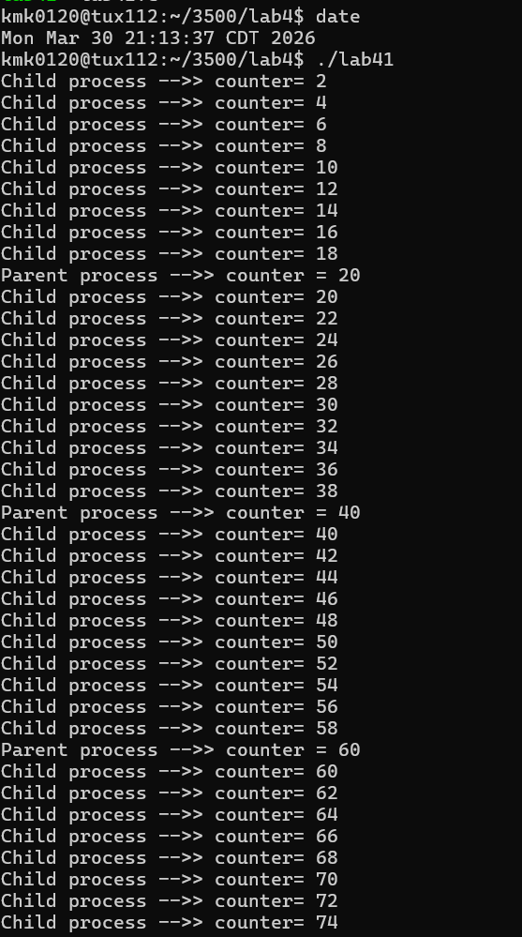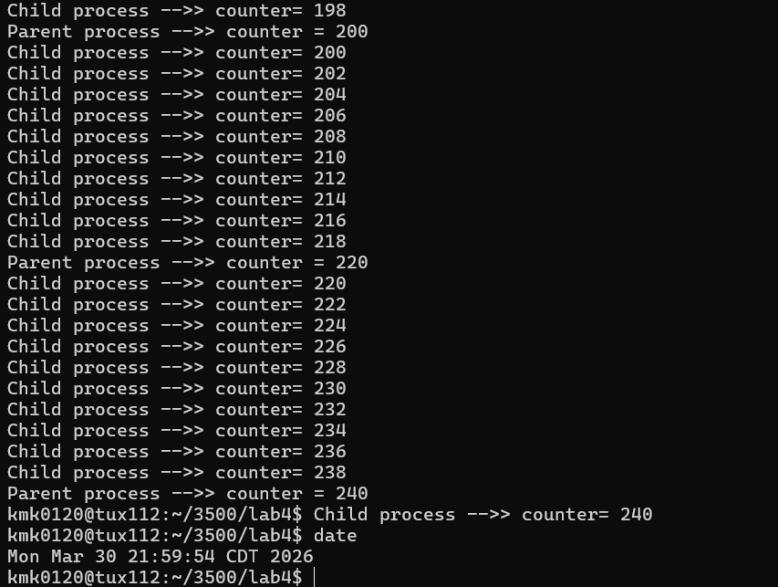
2) (8 points) Is the variable *countptr really a shared (common) variable? In other words, are the changes made to *countptr by the child visible by the parent, and vice versa? Describe/Justify/Explain.
Answer here ... No they are not visible because the fork() system call makes it so the child process is a different memory space with a copy of the variables from the parent, but since they are in a different memory space the variables of each process are independent and thus update separately without being visible to the other process.
3) (6 points) Can the shared data problem arise with the program lab41.c? Answer/Justify/Explain
Answer here ... No the shared data problem cannot arise with the program lab41.c because the fork() system call puts the child process in a completely separate memory space then the parent with a copy of variables in the new memory space. Therefore the child process memory call has completely independent variables even if they are a copy, they are in a different memory space. So the parent and child processes don’t actually share any memory space or variables. The child is just a copy in a different memory space so it looks like they are updating the same counter, when they are updating separate ones in different memory spaces.

Exercise 2 (30 points):
For this exercise, the instructor modified lab41.c to create a genuine shared variable *countptr. The variable *countptr is now shared by the parent and the child. If the parent process modifies *countptr, the child process "sees" the change. Similarly, if the child process modifies *countptr, the parent process "sees" the change. By modifying lab41.c, the instructor created a new program lab42.c. You do not need to understand the details about how the shared variable is created. Download, compile (cc -o lab42 lab42.c), and execute (./lab42) the program lab42.c.
1) (6 points) Based on the execution, show that *countptr is now a genuine shared variable (countptr points to a zone shared by the parent and the child). Now, are the changes to *countptr made by the child visible by the parent?
Answer here ... *countptr is a genuine shared variable because the parent and child processes don’t follow separate continuous patterns. The parent process updates the counter to 40 then 81 to 121 to 161 to 200 to 240. Thus, first making its counter to 40, then next time being 41 higher, then being 40 higher, then being 40 higher again, then 39 higher, then 40 higher. Thus, the parent counter doesn’t follow a pattern of incrementing, showing it is not updating the counter independently. And the child process seems to increment the counter by 4 typically but towards the end sets counter to 237, then the parent sets counter to 240, then child sets counter to 240. This shows it also doesn’t follow a pattern and must be being influenced by other things. Therefore, the processes are using a genuine shared variable, *countptr. The changes to * countptr made by the child are visible to the parent because instead of incrementing from 20 or the previous number of counter set by the parent process, the parent process always is an increment of the previous child process number of counter and does not follow a pattern of counter from the first parent process, throughout, till the last. Thus, it must be being influenced by the child process changing counter and therefore “sees” the changes”. When the parent process executes it increments from the previous value of the child process showing they share the memory for that variable and the parent sees the changes the child makes.
2) (24 points) Does the program really execute as supposed (or intended), i.e, the counter increases exclusively in increments of 2 or 20? Explain what is happening.
Answer here ... (Include a screenshot) No the program does not execute as its supposed to. As you can see from the screenshot below the execution of program lab42.c starts with the child process setting counter to 5, which is not an increment of 2. The child process then seems to increment by 4 most the time. The the parent process increments th value of counter to the next variable of 20 unless the previous child process is already incremented to a value divisibly by 20 in which the parent process seems to just increment by 1. The child process then seem to continue incrementing by 4 from the previous child process value of counter. This continues till the parent process sets the counter to 240 and the child process doesn’t increment it anymore from there. It seems like the processes are sharing the same data but irregulary increment by different variables. The race condition is causing the processes to read and write simultaneously and the *countptr system call is not atomic and thus the updates of the two processes are overlapping and causing the counter to increment ireggularly. The two processes share the same memory for counter but are not synchronizing the operation *countptr.
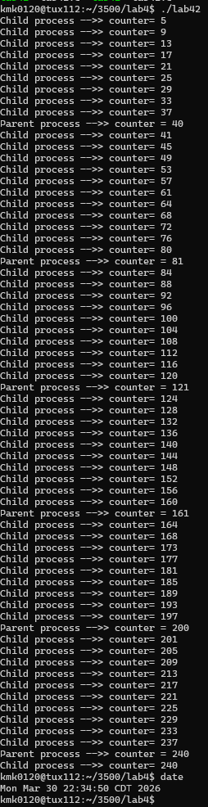

Exercise 3 (20 points):
The instructor decided to use the Peterson Solution to synchronize the parent and the child processes such that the CPU scheduler does not context switch when the procedure (method) add_n is executed. The idea is to set the method add_n as the critical region. For this, the instructor modified the program lab42.c to produce the program lab43.c. In the program lab43.c, the instructor created the variables *turnptr, *Interested0ptr, and Interested1ptr. In this exercise, your mission is to decide whether the instructor did a good job. If he did not implement correctly the Peterson Solution, you must correct the entry code or the exit code that may be buggy. Download, compile (cc -o lab43 lab43.c), and execute (./lab43) the program lab43.c.

1) (10 points) Does the program really execute as supposed (or intended), i.e, the parent and the child processes cooperate to increase *counter by jumps 2 or 20? Explain what is happening.
Answer here ... (Include a screenshot) No the program doesn’t execute correctly. The parent starts first incrementing by 20 as its supposed to, but then the child process increments by 4. Then the parent increments by 18. They continue this with the child also incrementing irregularly by 5 sometimes and the parent irregularly by 17. They are using the same shared variable and updating it but the amount is wrong and occasionally irregular.
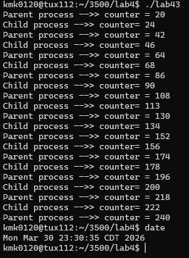

2) (10 points) The instructor did not implement correctly the Peterson’s solution to correct the program lab42.c. to execute as intended: the variable should increase by 2’s or twenty’s. Locate in C program the exit and entry codes in the parent and child processes. Try to correct, if necessary, these entry and exit codes (Refer to the lecture). Describe the changes you made to the program lab43.c. For this spell out each buggy instruction and spell out the change you made.
Answer here ... The child entry code starts saying the child is uninterested. It should indicate it is interested so I changed Intrested0ptr = 0 to be = 1 instead. The child should start wanting to enter. In the parent exit code it sets Intrested1ptr = 1 which is wrong because then parent can hog the critical section because it continues to say it is interested even after exiting. Thus I changed it to = 0 once the parent is in exit section. So now they take turns and increment appropriately. The incrementation is shared and synchronized. 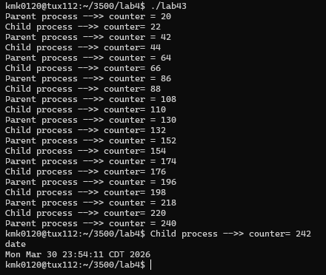

Do not hesitate to ask questions on Piazza if you have any doubt.
Common mistake
Starting the hands-on lab at the last minute.

What to turn in?
Two files:
a) Electronic copy of this file that includes your answers. I repeat: you must insert your answers in this file. Do not delete anything from this file. This file with your answers must be put posted separately on Canvas (not in a zipped folder).
Good writing and presentation are expected.
b) Modified C Program lab43.c. This is the C program containing your modifications of the Peterson's Solution.

In case of doubt, do not hesitate to ask questions on Piazza.

What you need to turn in:
- Electronic copy of this file (including your answers) (standalone). Submit the file as a Microsoft Word or PDF file.

- Recall that answers must be well written, documented, justified, and presented to get full credit.

- How this assignment will be graded:
- A right answer will get full credit when:
- It is right (worth 25%)
- It is right AND neatly presented making it easy and pleasant to read. (worth 15%)
- There is an obvious and clear link between 1) the information provided in the exercise and in class and 2) the final answer. A clear link is built by properly writing, justifying, and documenting an answer (worth 60%).
- Calculation mistakes will be minimally penalized (2 to 5% of full credit) while errors on units will be more heavily penalized.

- You are welcome/encouraged to discuss exercises with other students or the instructor. But, ultimately, personal writing is expected.

Appendix: Grading: What is an OBVIOUS and CLEAR LINK?
Here is an example to explain what an obvious and clear link is and how we grade your work.
Consider the following problem:
"(100 points) John travels from Auburn to Atlanta in his car at a speed of 50 mph. Leaving at 8am, at what time will John reach Atlanta".
Here are the answers of three students and their scores:
Student 1 answers: "10am". Student 1 will get 25 points.
Student 2 answers : "John will reach Atlanta at 10am". Student 2 will get 25+15 = 40 points
Student 3 answers: "The time t to travel a distance d at speed v is equal to d/v = d/50mph. The problem does not provide the distance d from Auburn to Atlanta. Based on Google, the distance from Auburn to Atlanta is approximately 100 miles (document is here). Therefore, the time t = 100 miles/50mph = 2 hours. Since John left at 8am, he will then reach Atlanta at 8am + 2 hours = 10 am".
Student 3 will get 25 + 15 + 60 = 100 points
Do you see the direct link going from the data provided in the question to the final answer, using general knowledge/formula and documents?.... Can you now solve the following problem and get 100 points?
"(100 points) Alice travels from Auburn to Atlanta in her car at a speed of 50 mph. Leaving at 8am, at what time will Alice reach Atlanta assuming that she had a flat tire that delayed her 30 minutes".

Screenshot: Required Information
In order to save space, for this assignment and all FUTURE ones, clip out the screenshots to contain only the relevant information. When applicable, ALL screenshots must show the date, the Tux machine you are using for the exercise and the Auburn username of one of the team mates. Make sure that the screenshots are easily readable. Below is template screenshot:

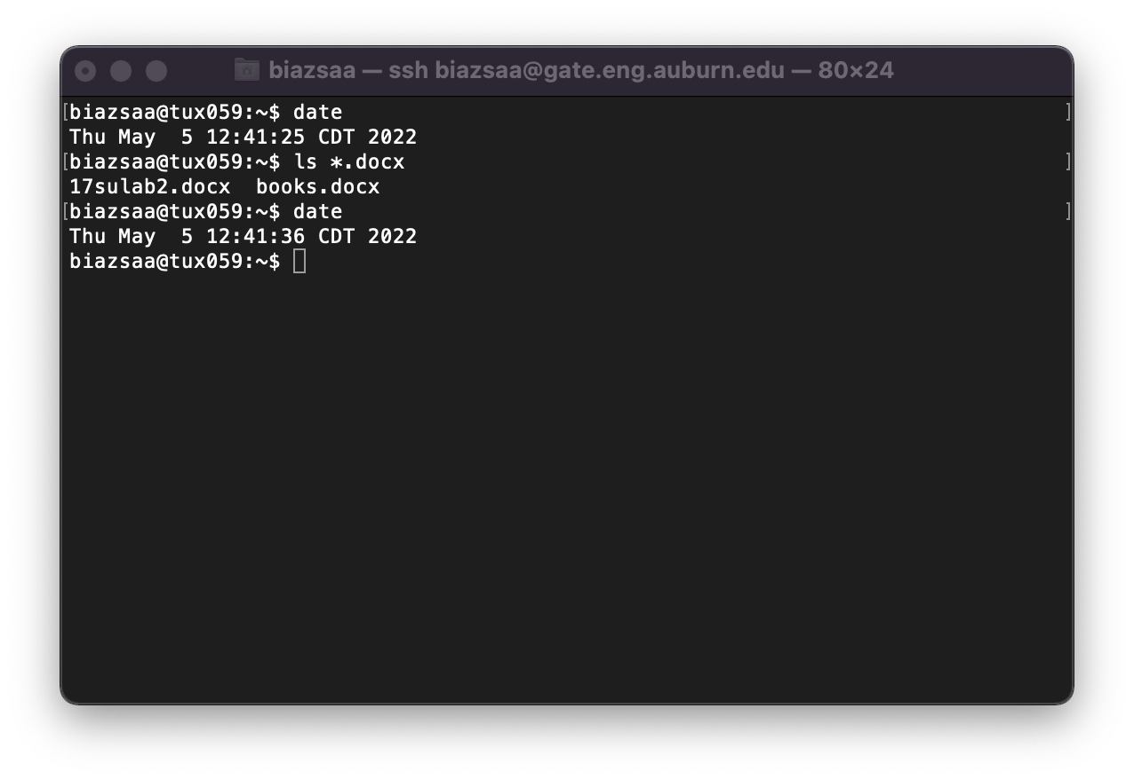

See on the appendix what an obvious and clear link is.
Recall the required information for ALL screenshots. See Appendix.

